# **FIND A JOB/WORKER IN TOTAL SECURITY**

## **Group Team:**

| Name |  | Campus ID | Email |
| --- | --- | --- | --- |
| Aurore Fritreau |  | 032264451 | aurore.friteau01@student.csulb.edu |
| Richard Perez |  | 032038472 | richard.perez01@student.csulb.edu |
| Thanh Nguyen |  | 031661420 | thanh.nguyen05@student.csulb.edu |
| Brandon Chau |  | 028171804 | brandon.chau01@student.csulb.edu |
| Bryan Estrada-Cordoba |  | 028776031 | Bryan.Estrada-Cordoba01@student.csulb.edu |

## 

## 

## 

## 

## 

## 

## 

## 

## 

## **Log of dates and changes:**

| 11.01.2023 | Created the introduction; Created the GitHub repository, |
| --- | --- |
| 11.02.2023 | Created the Introduction; Added the user stories; Created Use Case #1 |
| 11.03.2023 | Created Use Case #2 and #3 |
| 11.04.2023 | Revised Use Cases #1 - #3; Constructed the Product Backlog |
| 11.05.2023 | Created Sequence Diagram; Finalized document |

**INTRODUCTION**

The purpose of our system is to help employers find and hire local workers to complete a job request.

Major Features of Our System:

* Profile Page for Employer
  + Profile page contains a picture, name and phone number
* Profile Page for Worker
  + Similar to profile page as an employer with the addition that workers can add their skillset
* Employer Job Postings
  + Our application allows employers to post a job request as well as the necessary skills required to complete the job request
* Search and Match
  + Our application searchings for local workers that meet the skillset required by the job posting and displays a chronological list of a potential workers to the employer
* Rating and Reviews
* Secure Payment Processing

## **GLOSSARY:**

## **USERS STORIES:**

**Scenario 1:** As an employer, I can hire a local worker so that they can complete a job for me.

**Scenario 2:** As a worker, I can receive a job request so that I can work.

**Scenario 3:** As an employer, I can rate a worker so that my opinion about their performance is shared with other employers.

**Scenario 4:** As a worker, I can chat with an employer about the details of a job before accepting the job

**Scenario 5:** As a worker, I can securely receive my payment so that I get compensated for my work.  
**Scenario 6:** As a worker, I can rate and review an employer so that I can help influence the decisions of other workers in a supportive way.

**Scenario 7:** As a worker, I can see a list of potential job offers.

**Scenario 8:** As a worker, I can accept/reject any potential offers.

**Scenario 9:** As a worker, I can update my progress so that the employer knows how much work I’ve completed.

**Scenario 10:** As an employer, I can track the worker's progress so that I know how much work they've completed.

## **USE CASE:**

**Use case #1:** Rating the Worker at the end of the contract.

| **Sequence #** | **Actor’s Actions** | **System’s Actions** |
| --- | --- | --- |
| 1 | Worker completes the job request and updates their progress in the app |  |
| 2 |  | Our app notifies the employer that the worker completed the job request |
| 3 | Employer verifies that the job is complete and confirms in the app |  |
| 4 |  | Our app sends an optional review to the employer to rate the worker |
| 5 | The employer completes the review and publishes it |  |
| 6 |  | Our app stores the review in the database associated with this specific worker |

Alternate Course of Action

| **Sequence #** | **Actor’s Actions** | **System’s response** |
| --- | --- | --- |
| 1 |  | Our app sends an optional review to the employer to rate the worker |
| 2 | The employer rates the worker but does not write a review |  |
| 3 |  | Our app stores the rating in the database associated with this specific worker |

Exception Course of Action

| **Sequence #** | **Actor’s action** | **System’s response** |
| --- | --- | --- |
| 1 |  | Our app sends an optional review to the employer to rate the worker |
| 2 | The employer rejects the optional review to rate the worker |  |

**Use Case #2: An Employer Puts Out a Request for a Job**

*Main Flow*

| **Sequence #** | **Actor’s Actions** | **System’s response** |
| --- | --- | --- |
| 1 | An employer puts out a request for a job in the app |  |
| 2 |  | Our app displays the potential job offer to qualified workers in the local area |

*Alternative Flow*

| **Sequence #** | **Actor’s Actions** | **System’s Actions** |
| --- | --- | --- |
| 1 | An employer puts out a request for a job in the app |  |
| 2 |  | Our app displays the potential job offer to qualified workers in the area |
| 3 |  | Our app doesn’t find qualified workers in the area and in response expands the search radius to find qualified workers |
| 4 |  | Our app displays a list of potential workers to the employer |

*Exception Flow*

| **Sequence #** | **Actor’s Actions** | **System’s Actions** |
| --- | --- | --- |
| 1 | An employer puts out a request for a job in the app |  |
| 2 |  | Our app displays the potential job offer to qualified workers in the area |
| 3 |  | Our app displays a list of potential workers to the employer |
| 4 | The employer cancels the job request |  |
| 5 |  | Our app removes the job request from the database |

**Use Case #3: A worker is hired for to provide a service**

*Main Flow*

| **Sequence #3** | **Actor’s Actions** | **System’s Actions** |
| --- | --- | --- |
| 1 |  | Our app displays a list of potential job offers to the worker |
| 2 | A worker accepts a job request from the list of potential job offers |  |
| 3 |  | Our app displays a message telling the worker that they have been hired to complete the job request and displays the details of the job request as well as the contact information of the employer |

*Alternative Flow*

| ***Sequence #*** | ***Actor’s Actions*** | ***System’s Actions*** |
| --- | --- | --- |
| *1* |  | Our app displays a list of potential job offers to the worker |
| *2* | A worker rejects a job offer from the list of potential job offers |  |
| *3* |  | Our app updates the list of potential job offers by removing the rejected job offer from the list and shows the remaining potential job offers |
| 4 | The worker accepts a job request from the list of potential job offers |  |
| 5 |  | Our app displays a message telling the worker that they have been hired to complete the job request and displays the details of the job request as well as the contact information of the employer |

*Exception Flow*

| **Sequence #** | **Actor’s Actions** | **System’s Actions** |
| --- | --- | --- |
| 1 |  | The worker does not have a skillset that matches any local potential job offers and thus our app displays a message to the worker that there are zero potential job offers available |

**Sequence Diagram:**

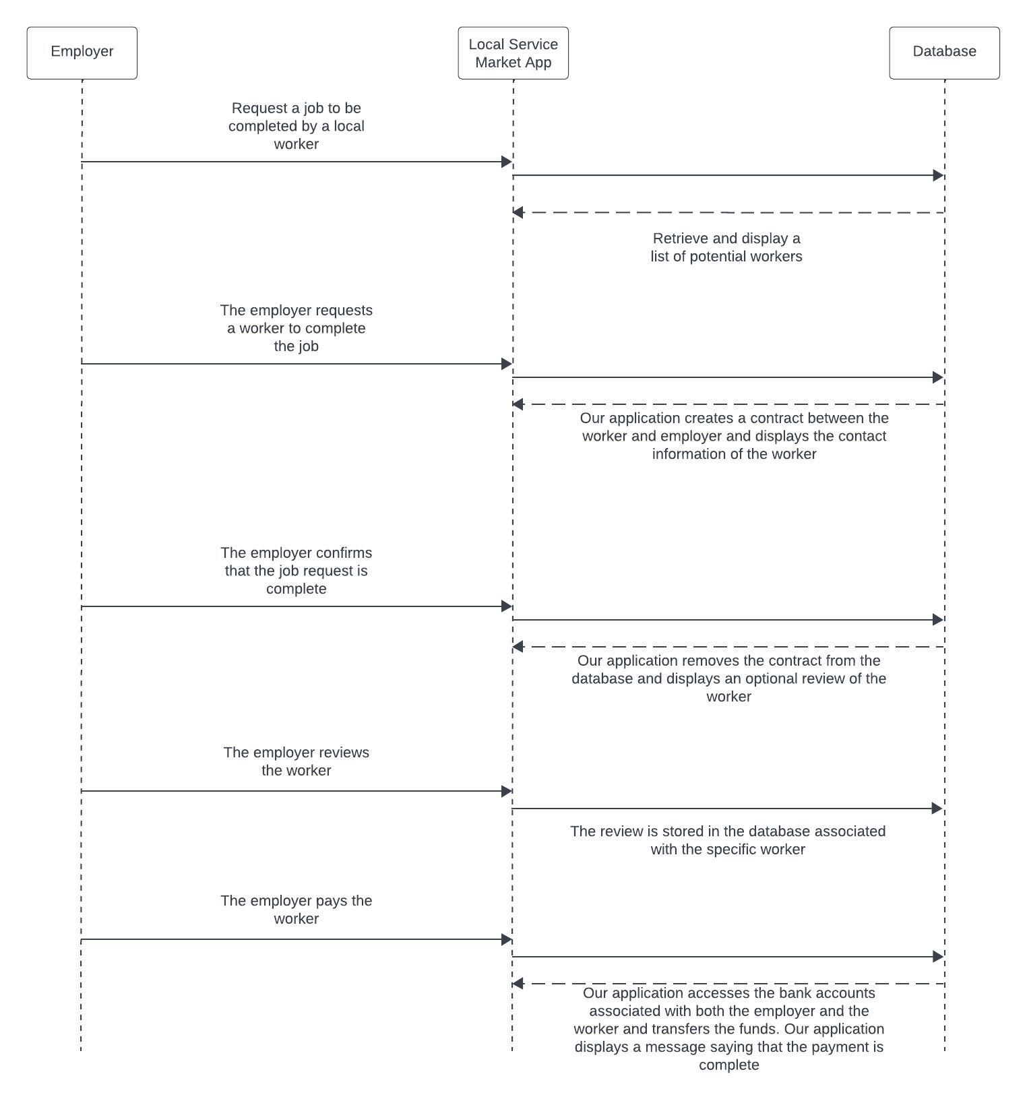

**PRODUCT BACKLOG:**

**Local Service Market on app**

| **ID** | **Description #Sprint**  **Effort needed for Release 1 as in the beginning of the Sprint** | 1  104 | 2  48 | 3  22 | 4  0 | 5  0 |
| --- | --- | --- | --- | --- | --- | --- |
| 1 | Set up continuous integration system | 10 | 0 | 0 | 0 | 0 |
| 2 | Create compilable application skeleton | 10 | 0 | 0 | 0 | 0 |
| 3 | Create workers can store their skills | 8 | 0 | 0 | 0 | 0 |
| 4 | Create employers | 8 | 0 | 0 | 0 | 0 |
| 5 | Make an UI can show all the workers | 20 | 0 | 0 | 0 | 0 |
| Sprint 1 | Make a run to try the UI and database work well |  |  |  |  |  |
| 6 | Make payment system | 10 | 10 | 0 | 0 | 0 |
| 7 | add image to workers and employers profile | 3 | 3 | 0 | 0 | 0 |
| 8 | make when worker accepted the employer request  they will both be in contact. The worker can’t accept another request until this is done. | 3 | 3 | 0 | 0 | 0 |
| 9 | Make an online chat for worker and employer | 5 | 5 | 0 | 0 | 0 |
| 10 | Make a rating system | 5 | 5 | 0 | 0 | 0 |
| Sprint 2 | Minimal working version |  |  |  |  |  |
| 11 | implement support for location | 10 | 10 | 10 | 0 | 0 |
| 12 | securely receive funds | 7 | 7 | 7 | 0 | 0 |
| 13 | post review in worker profile | 5 | 5 | 5 | 0 | 0 |
| Sprint 3 | Run the app in the real situation |  |  |  |  |  |
| Release 1 | Sellable version |  |  |  |  |  |
| 14 | Project bidding | 10 | 10 | 10 | 10 | 10 |
| 15 | Track the worker’s progress | 7 | 7 | 7 | 7 | 7 |
| 16 | Plug real ads in | 40 | 40 | 40 | 40 | 40 |
| Sprint 4 | Advertisements support and new functions |  |  |  |  |  |
| Release2 | Ad-supported and implemented new functions |  |  |  |  |  |
|  | **Effort in the whole backlog** | 161 | 105 | 79 | 40 | 40 |

